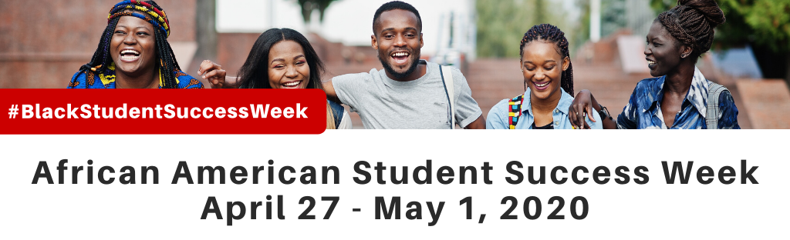

African American Student Success Week is an effort to share research insights and provide support services for improving student success among Black and African American students at California Community Colleges. A series of webinars were held throughout the week to inform participants of how best to advocate for and support this student population. Below you will find the webinar recordings for each webinar.

Monday, April 27
Recommendations to Improve the Success of African American Students
- Download the PowerPoint
- Webinar Recording – NOTE: CCC Confer Zoom Recording Unavailable

Tuesday, April 28
Housing Insecurity of African American Students
- Download the PowerPoint
- Webinar Recording

Wednesday, April 29
Making the Case for African American Student Success
- Download the PowerPoint
- Webinar Recording

Thursday, April 30
Meeting the Educational Needs of Black Students During and After COVID-19
- Download the PowerPoint
- Webinar Recording

Friday, May 1
Student Voices: The Transfer Journey for African American Students to HBCU, CSU and UC
- Download the PowerPoint
- Webinar Recording

To view all of the webinar recordings on Community College League of California’s YouTube channel, click here. Choose the playlist “African American Student Success”.

